FINISH LINE TIRE CENTER

Contact Information
Tel: +1-897-335-8836
Fax: IUJG-3097
Email: Fnline@yahoo.com
Box: 3727-9468 MOONLAND.
Caught in the night! This is how you could change a flat tire.
Knowing how well to change a flat tire could be an important skill for drivers. However, this is a skill that many people lack and always find themselves in a fix once the unexpected happens. Imagine driving late at night with your family on I-94 going on a road trip to Wisconsin, and suddenly a specific indicator on the dashboard started signaling “Check tire pressure.” These are important steps that one could use to get the problem solved.
THE FOLLOWING ARE THE ITEMS YOU NEED
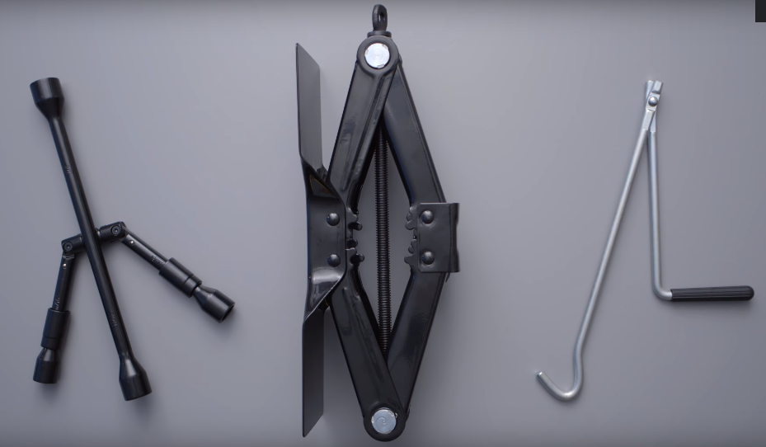
Lug wrench
- Jack
- Fully inflated spare tire
- Vehicle owner’s menu
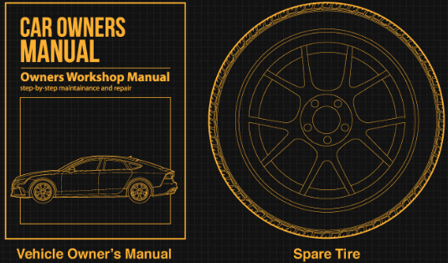
- Wheel wedges
- Gloves
- Rain Poncho
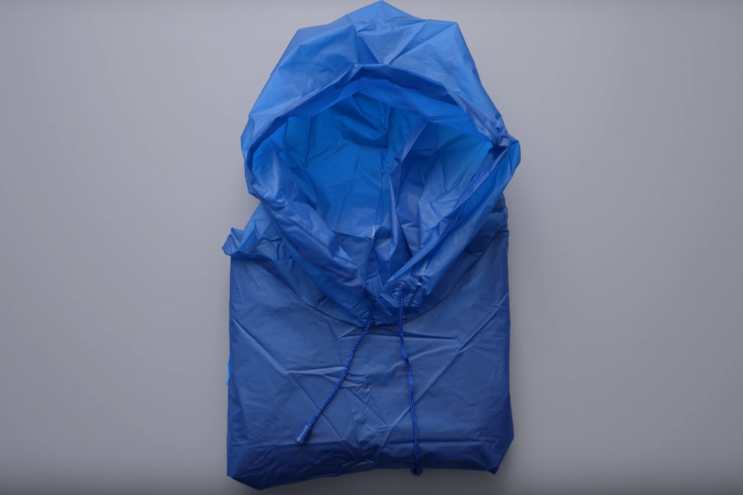

- A working Flashlight
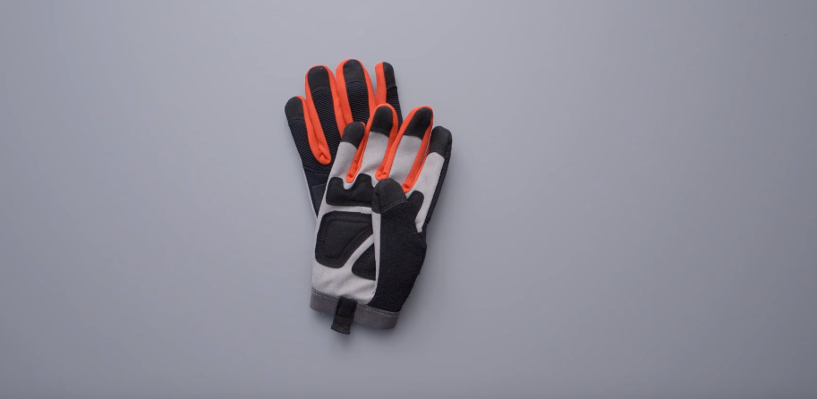
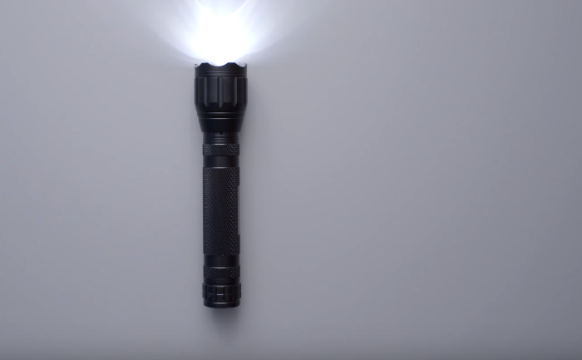
Steps on how to change the flat tire
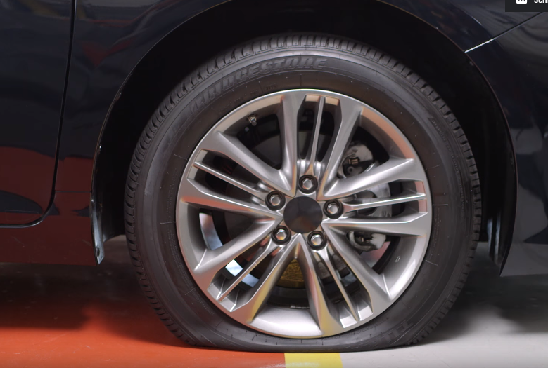
- Find a safe location
Do not make abrupt brakes in case you realize you have a flat tire. Reduce the speed gradually.
Consider your safety. Look around and see whether you can find an empty parking space, which is well leveled. This is important to prevent the rolling of the vehicle.
Do not try to change the tire near the oncoming traffic. Make sure you don’t travel for long while looking for a safe parking because this might damage the rim of the tire. However, it is better to replace a rim than get hit by an ignorant/inattentive driver.
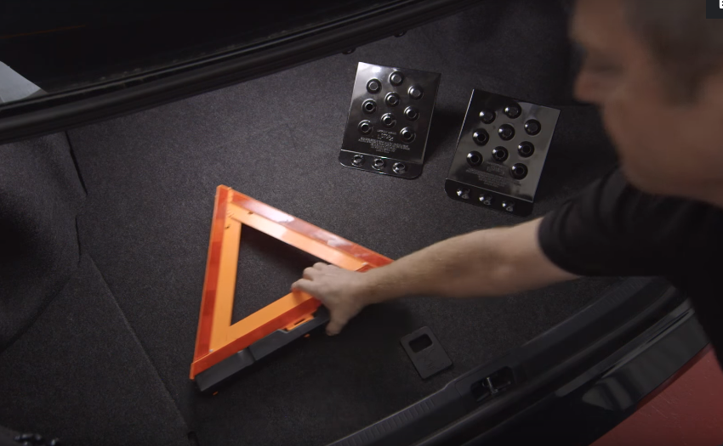
- Switch on the Hazard lights
The hazard lights will help other drivers to you on the roadside and avoid an accident. It is important to turn them on when pulling over.
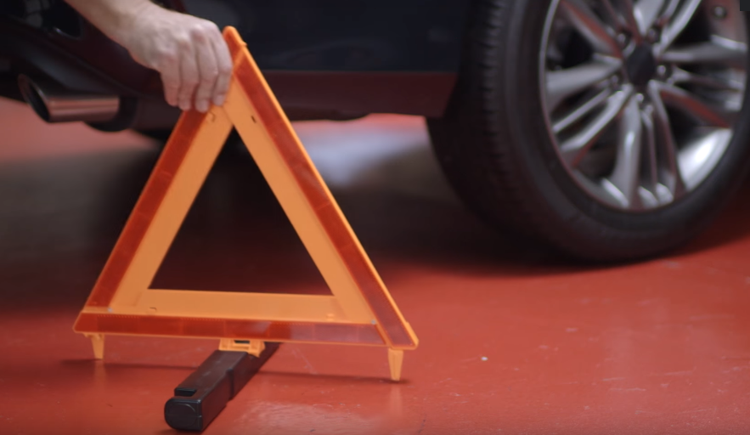
- Apply the parking brake
It is important to apply the parking brake wen replacing the flat tire. This minimizes any chance of the vehicle rolling.
- Apply the wheel wedges
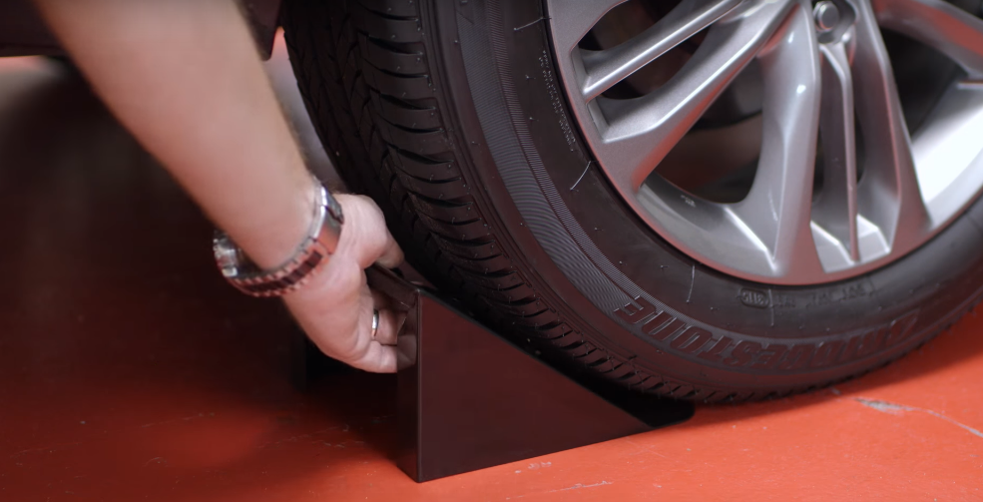
Wheel wedges should be placed behind the tires in order to ensure that the vehicle does not move when replacing the flat tire. When changing the behind tire, put the wedge at the flat tire(s). If changing the front tire, put the wedge at the behind wheel(s).
- Remove the wheel cover or the hubcap
When the vehicle has a hubcap that are covering the lug nuts, remove them first before lifting the vehicle while using the jack. If the lug juts are exposed, kindly skip to step 6. Loosen the lug nuts
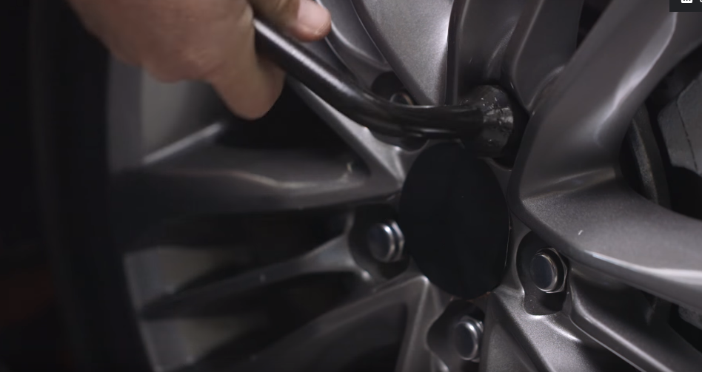
Use the lug wrench to turn the lug nuts counterclockwise until they tilt. Use force as some might be very tight. You can use your foot and body weight to turn the lug nuts.
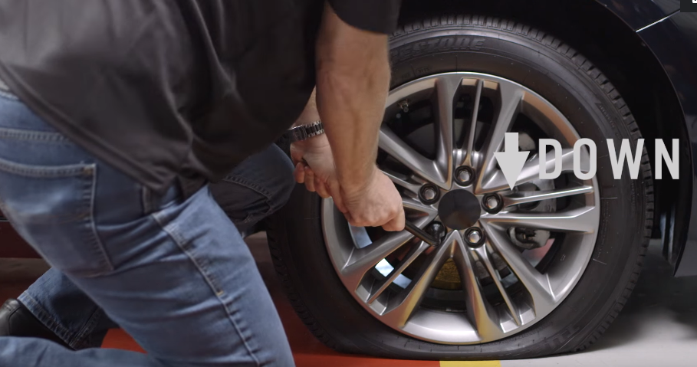
- Place the jack under the vehicle
The jack is placed under the vehicle alongside the flat tire.
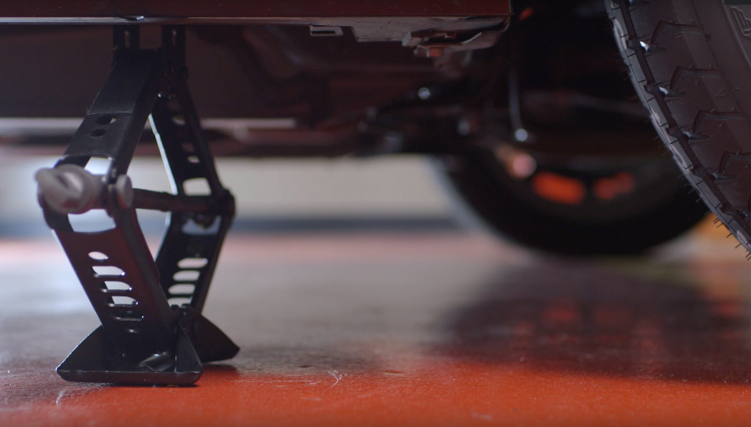
Check the material beneath the body to avoid placing the jack under a molded plastic bottom, use the clear, and exposed metal parts to place the jack. Lift the vehicle safely
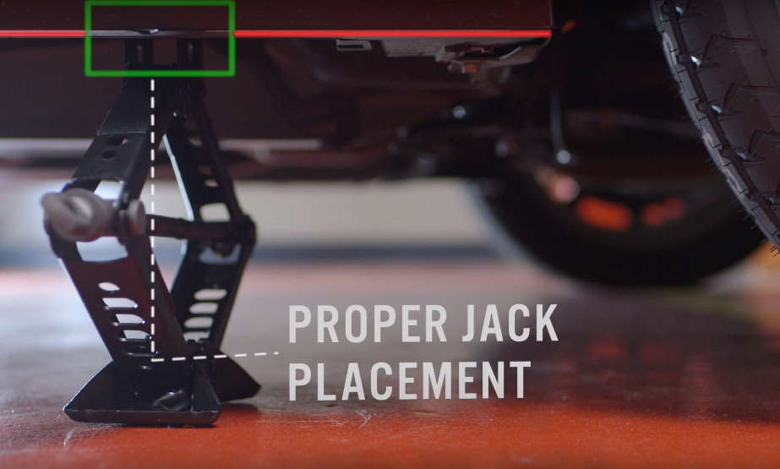
- Raise the vehicle with the jack
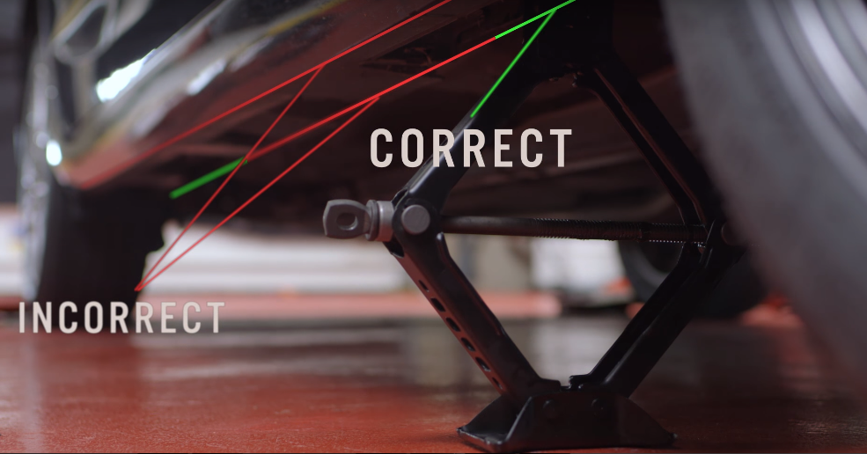
In order to prevent the jack from the setting on a soft ground that might sink on the process of lifting the vehicle, you can use a small cut of wood to place the jack on. Place the jack safely and raise the vehicle to approximately six inches off the ground.
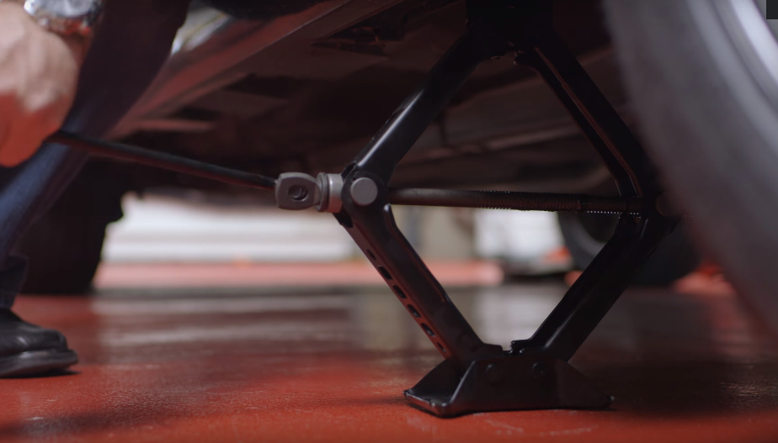
NOTE: Do not place any body part under the lifted vehicle.
- Unscrew the lug nuts
Remove the lug nuts after loosening them, screw them by hand.
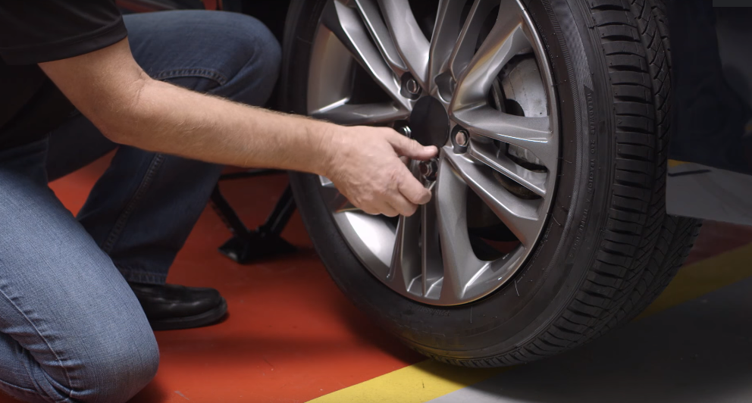
- Safely remove the flat tire
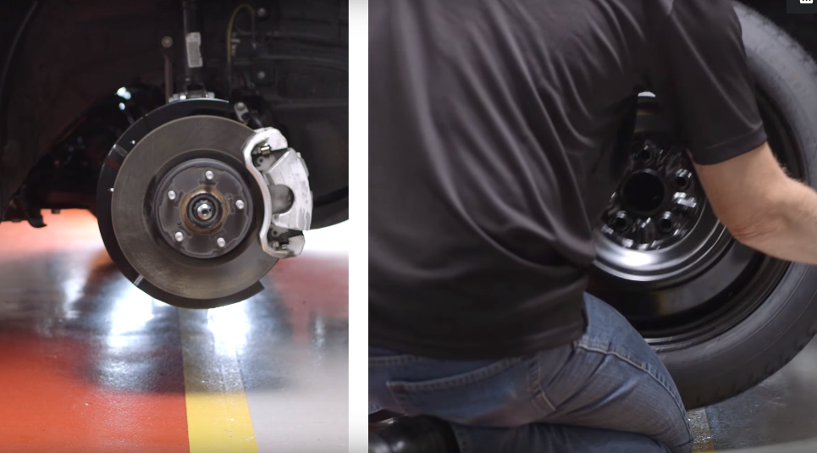
Grip the tire by gripping by the treads and gently remove the tire until it is free from the hub behind.
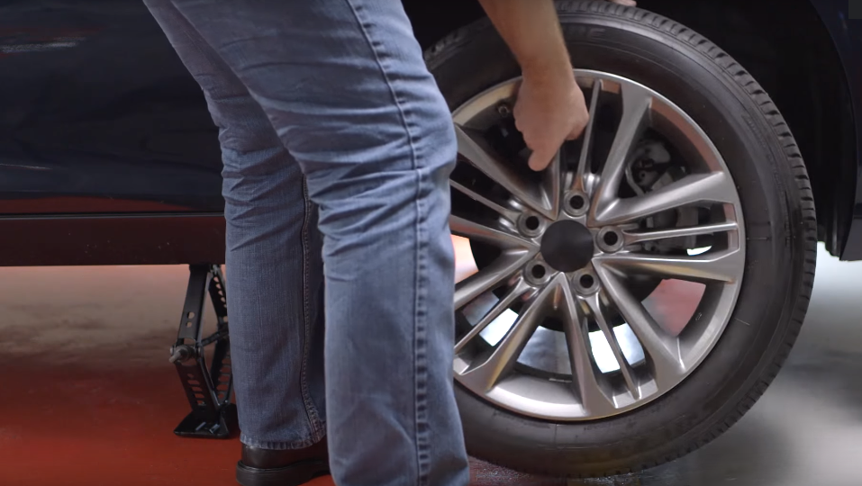
- Mount the spare tire on the lug bolts
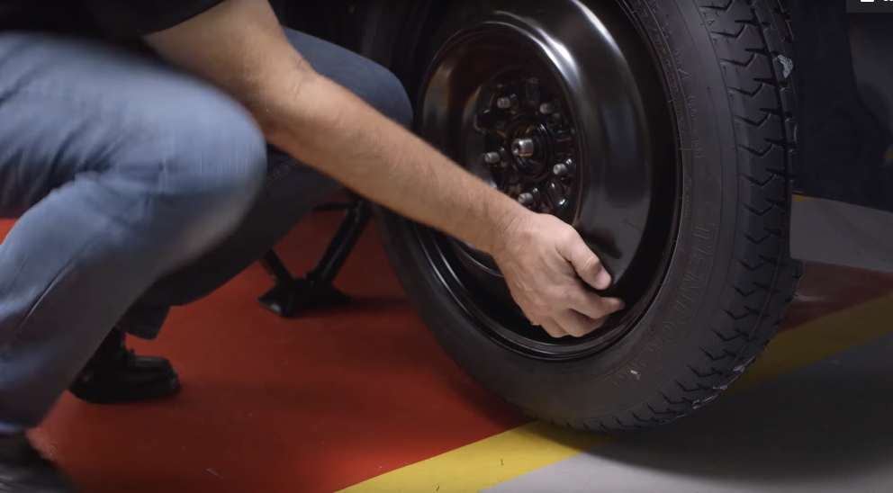
Place the spare on the hub by lining up the rim with the lug bolts and push gently the lug bolts show via the rim
- Tighten the lug nuts by hand
Place the nuts back on the lug bolts and begin the tightening process.
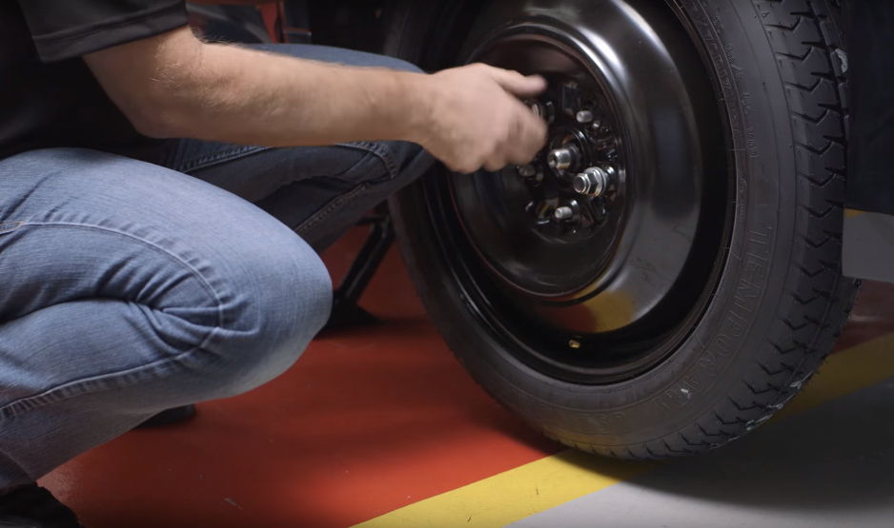
Start doing it first by hand then tighten them using the wrench immediately after lowering the vehicle to the ground.
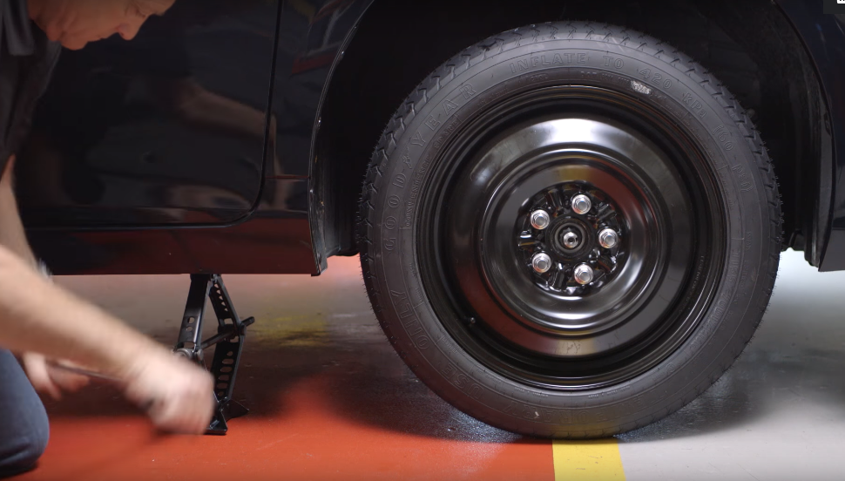
- Lower the vehicle and tighten the lug nuts once more
Lower the vehicle using the jack and make sure that the tire is fixed properly.
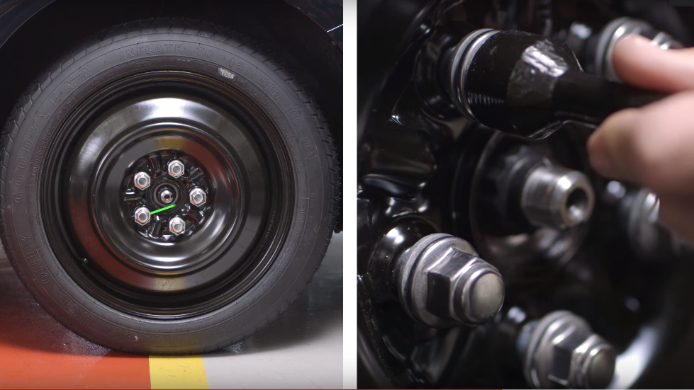Make sure the lug nuts are tight by turning them clockwise up the maximum level. You can use the body weight to push down the wrench.
- Lower the vehicle completely flat on the ground
Remove the jack
- Replace the hubcap
Check whether the hubcap fits in the spare tire and if it does, place it. If it doesn’t keep it for the next installation of the flat tire once repaired.
- Store all equipment
Store all the equipment in the toolbox, the flat tire, and maybe the hubcap in the vehicle.
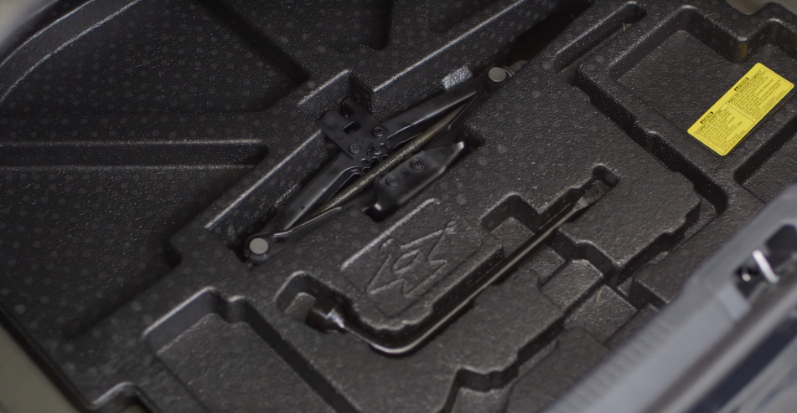
- Confirm the spare tire pressure.
Make sure that the tire pressure is okay to drive on. It requires about 420kPa.
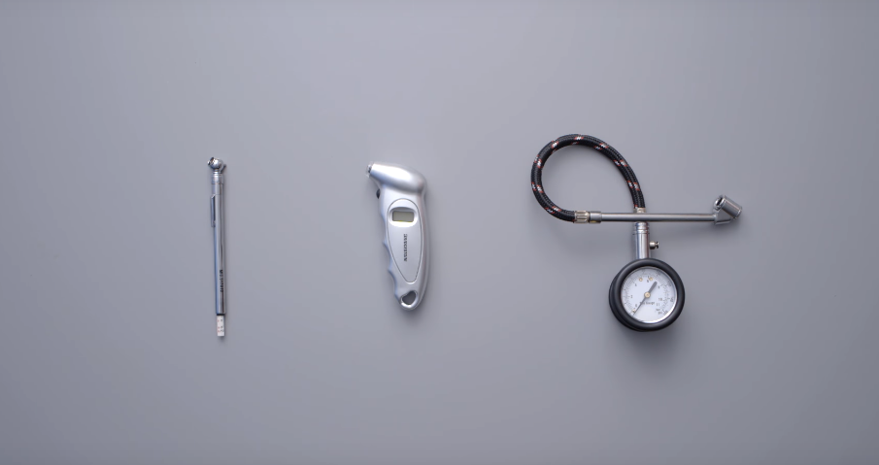 If it is not, drive to the nearest service station and inflate it up to the required pressure.
- Take the flat tire for repair
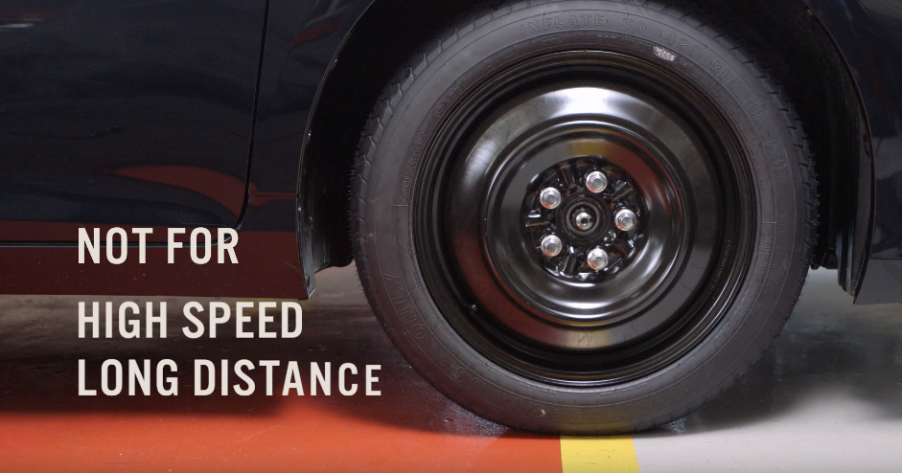
The spare tires ought not to be used for long distances or for high speeds. Once repaired replace the spare tire.

